ORDER TYPES – MATCH UP WITH CATEGORIES

[Existing management of order types on current website]

PET OWNER

<https://trustmypetsitter.com/en/admin/listing_shapes/pet-owner/edit>

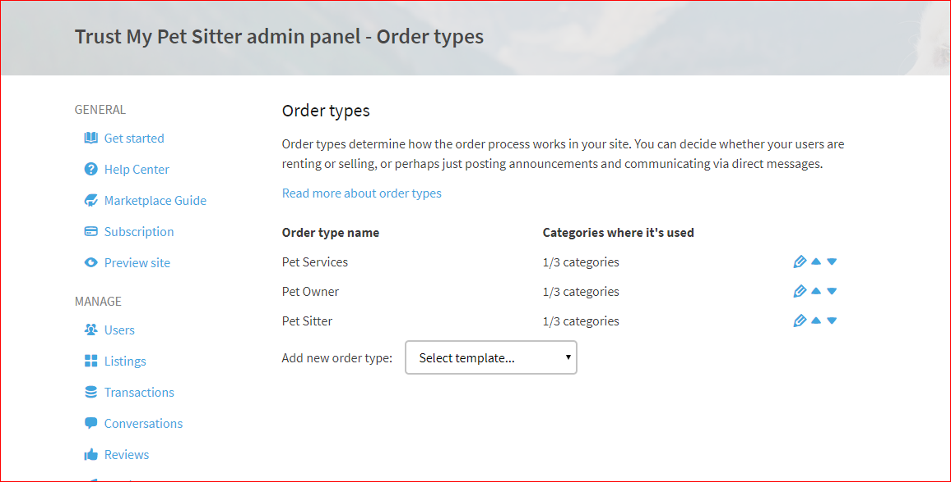

**Pricing and Checkout**

Options

Allow seller to add a price to their listing – NO

Allow sellers to accept payments online – NO

Allow sellers to define a shipping fee – NO

Availability [Understand how availability works on our old website see this article: <https://help.sharetribe.com/en/articles/666089-manage-booking-availability-per-day-and-per-night> ]

**Allow sellers to manage availability from a calendar** – YES

Per hour – no

Per day – no

Per night – no

**Pricing Units**

Per unit – no

Per hour – no

Per day – no

Per night – no

Per week – no

Per month – no

ORDER TYPES – MATCH UP WITH CATEGORIES

PET SITTER

[Existing management of order types on current website]

<https://trustmypetsitter.com/en/admin/listing_shapes/sitter/edit>

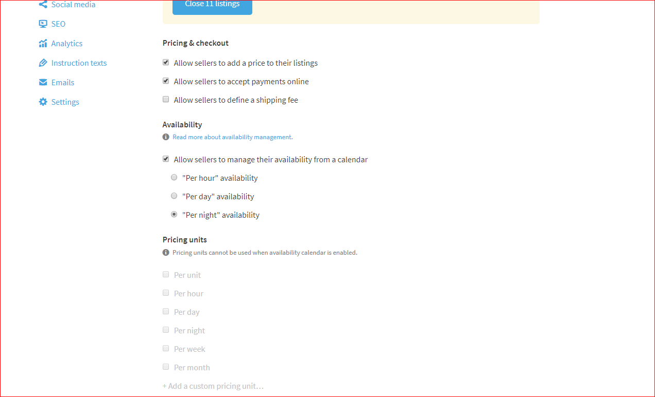

**Pricing and Checkout**

Options

Allow seller to add a price to their listing – yes

Allow sellers to accept payments online – yes

Allow sellers to define a shipping fee – NO

Availability [Understand how availability works on our old website see this article: <https://help.sharetribe.com/en/articles/666089-manage-booking-availability-per-day-and-per-night> ]

**Allow sellers to manage availability from a calendar** – YES

Per hour – no

Per day – no

Per night – yes

**Pricing Units**

Per unit – no

Per hour – no

Per day – no

Per night – no

Per week – no

Per month – no

ORDER TYPES – MATCH UP WITH CATEGORIES

[Existing management of order types on current website]

<https://trustmypetsitter.com/en/admin/listing_shapes/pet-services/edit>

**PET SERVICES**

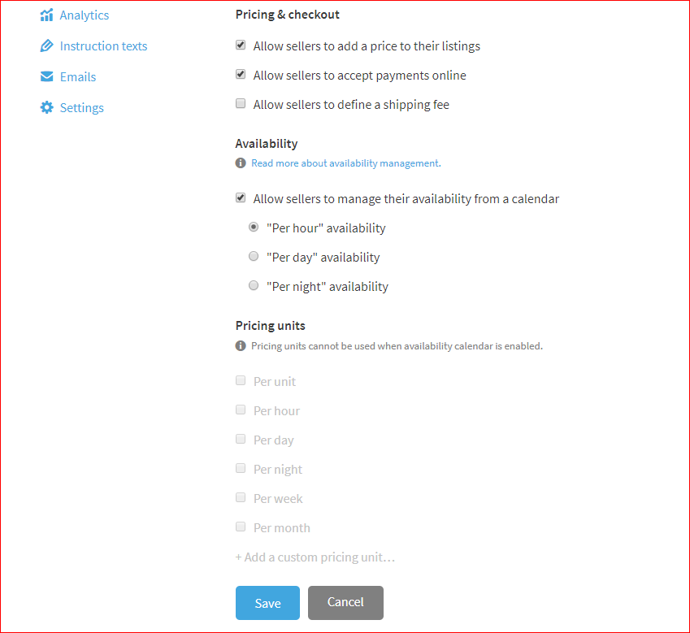

**Pricing and Checkout**

Options

Allow seller to add a price to their listing – yes

Allow sellers to accept payments online – yes

Allow sellers to define a shipping fee – NO

Availability [Understand how availability works on our old website see this article: <https://help.sharetribe.com/en/articles/666089-manage-booking-availability-per-day-and-per-night> ]

**Allow sellers to manage availability from a calendar** – YES

Per hour – YES

Per day – no

Per night – NO

**Pricing Units**

Per unit – no

Per hour – no

Per day – no

Per night – no

Per week – no

Per month – no